Gendered Digital Divide: The impact of the lack of women in STEM

Team 4

The Divide

Florida State University

LIS3201

Final Report

# **Abstract**

To determine the state of the gendered digital divide at Florida State University, data was collected from undergraduate students at Florida State University concerning their awareness of the gender digital divide, their perspectives on the matter, and, in some cases, how it has impacted their educational experiences in Science, Technology, Engineering, and Mathematics (STEM) classrooms. The purpose of this study is to examine the potential impacts of the gendered digital divide for college students in STEM. A survey was sent out to undergraduate students enrolled at Florida State University through various mediums; responses were recorded and analyzed after having reached a statistically relevant number of responses (75). The results demonstrate that female students are more aware of a gender digital divide in STEM classrooms than their male classmates, female students feel underrepresented in STEM environments leading to feelings of discomfort in their classes, and that both male and female STEM students feel as if they have equal access to the resources needed to succeed in STEM. As such, these responses showed that a STEM educational experience varies depending on the gender of a student. Based on this analysis, other institutions could conduct research on their undergraduate STEM population, so as to more fully understand the gendered digital divide in education at large.

Keywords: Gender, STEM, Digital Divide

# **Problem Statement**

When considering the domain of Science, Technology, Engineering, and Mathematics (STEM) university cohorts, a digital divide exists within the gender distribution of students. In specific, there are a disproportionate number of men enrolled in STEM majors compared to the female population size. As a result of a trickle-down-like effect, the demographics of STEM workplaces is impacted: According to the U.S. Census Bureau, in 2019, women made up 48% of all workers, yet only accounted for 27% of STEM related jobs (Martinez & Christnacht, 2021). The discrepancy can be attributed to the following logical track: Universities are institutions that prepare, educate, and equip students with the foundational skills necessary to enter the workplace as productive employees. As our society grows more technocratic, the number of employers that value and therefore hire employees with a STEM background is increasing. For example, McKinsey & Company estimates that between 2017 and 2030, the potential job growth for STEM professionals is near 40% (Lund et al., 2019).

As STEM students of Florida State University, it is believed that this research is pertinent to the success and outcomes of our undergraduate alumni. If university faculty can better understand the reasons that some students do not enroll in certain degree tracks, they may be able to remedy societal biases. In order to address those preconceived notions, university administration must first understand where gaps exist and subsequently investigate why. For these reasons, a study was designed to explore the relationship between the gender of FSU undergraduate students and their experience within the STEM programs at FSU.

# **Significance of Study**

The modern age: our finances are managed by networks of highly sophisticated algorithms, our homes are continually becoming a place to share with the Internet of Things, and soon, our laws will be largely policed by computers (Eggers et al., 2017). As all sorts of technologies continue to engrain themselves in society, it follows that whoever engineers the products has a large stake in the fabric of our lives. Logically, we need diverse representation if we ever hope to achieve any semblance of equality, or equity, between the members of our society. As stated, our group believes that the root of the growing imbalance in STEM gender representation worldwide can be tracked down to biases in education. To be clear, we believe that the skills and demographics of graduates who concentrate in STEM have a direct impact on the skills and demographics of employees who concentrate in STEM occupations. In order to address the gaps in the distribution of gender, research must be conducted to observe where the discontinuities exist and why they take place. Our research aims to conduct a close investigation into the relationship between gender and STEM participation in education at Florida State University.

For many reasons, we believe that increasing diversity in the STEM programs at FSU is a mutually beneficial relationship for both the graduate and the university. For one, increasing diversity and actively recruiting interest from communities that are underrepresented in the STEM workforce can directly impact the culture of a classroom. By allowing new perspectives, students may introduce novel problem solving strategies, which may lead to unique research opportunities for the university. Additionally, if the culture of a classroom diversifies, students who may have previously felt uneasiness with their participation in STEM may begin to feel more comfortable in their environment. For a university, this can lead to higher satisfaction within the program. An increase in satisfaction can influence the number of students that enroll in a program as well as the retention rate for a program; two important factors for ranking the quality of a university’s department.

Increasing diversity within STEM programs is also beneficial for universities after a student graduates, as employers are actively looking for diverse workers. A report conducted by the Harvard Business Review revealed that of 1,115 North American companies, 74% report that they track the diversity of new hires (Brown, 2021). A university that produces diverse talent is likely to create highly recruitable job candidates, which can reflect well on the quality of the education a university provides.

Our hope is that once a disparity has been discovered and sufficiently examined, a university may deploy targeted campaigns to engage with underrepresented demographics. Furthermore, an active effort to investigate and mediate this divide at our university can lead to replicable observations for supplementary research being done at other universities.

# **Research Questions**

RQ1: What effect(s) does the gendered digital divide have on the educational experience of FSU undergraduates?

RQ2: How do students at FSU recognize the Digital Divide between the number of women in STEM vs the number of men in STEM?

# **Environmental Scan**

**Introduction**

The mark of a generation is largely tied to the tools they utilize. In the 19th century, the Industrial Revolution and coal-powered steam engines changed nearly every aspect of urban life, and similarly, the 21st century has its own toolage to thank for life-changing advances. In the modern world, society has largely normalized the interaction between humans and computers. It has become increasingly common to adopt technology in the home. For instance, in 2015, the National Center for Education Statistics (NCES) reported that around 85% of children ages 3 to 18 lived in households with access to a computer (KewalRamani et al., 2018). As such, 15% of this population has limited interaction with technology. The concept of a gap existing between the technology haves and the technology have-nots is commonly referred to as the digital divide. When considering the digital divide, it is common to cluster populations based on different classifiers. For the purposes of this study, the gendered digital divide will be analyzed. That is, this study aims to analyze the discrepancies between male technological adopters and female technological adopters. We believe that the effects of the digital divide can be associated with stereotypes surrounding women and their interaction with technology, as well as academic policies and practices, which can in turn affect outcomes for employability and workplace relations for the digitally marginalized.

**Gender Norms**

The barriers for women to become involved with technology often reveal themselves through stereotypes concerned with the differences between men and women. These gender stereotypes can vary between cultures. For example, we will take note of the stereotypes about women in India who use cell phones. In 2018, a Harvard study determined that mobile phone usage for women in India carries cultural significance (Barboni et al., 2018). The research found that owning a mobile phone is viewed as a risk to the reputation of women, and their adoption of mobile phones is seen as a threat to their purity. For married women, extensive mobile phone usage was found to be a sign that a woman is not taking proper care of her children (Barboni et al., 2018). These biases can lead to women neglecting the use of technology, but they can also be internalized and prompt women to believe that they are less skilled than their male counterparts. To illustrate that point, when asked to rate their ability in utilizing internet tools, men are nearly twice as likely to describe themselves as having an excellent grasp (Liff & Shepherd, 2004). Similar research reveals that female students report ratings of feeling less comfortable and less confident about computer usage when compared to their male classmates' responses. These same women expressed anxiety at the prospect of using computers, which they proclaimed led to feeling “inhibited to pursue careers in technology” (Cooper & Weaver, 2003). The biases concerning women’s digital competency may provide an explanation for the lack of women entering Science, Technology, Engineering, and Mathematics (STEM) fields.

**Education**

Another explanation for why women make up less of the STEM workforce than men can be attributed to biases in education. In 2019, the Programme for International Student Assessment (PISA) surveyed the academic performance of 15 year old students in 67 countries. The survey found that 15 year old boys outperformed their female classmates in science assessments in 22 countries, while 15 year old girls outperformed their male classmates in science assessments in 19 countries (Mostrafa, 2019). For the remaining 26 countries, the performance differences in science assessments between boys and girls were deemed to be statistically insignificant. Across the board, the overall performance between 15 year old boys and girls was determined to be similar. As such, there is no clear intellectual advantage to indicate that men are more likely to aspire to scientific academic and post-academic pursuits due to their juvenile academic performance.

Yet, a disparity exists between men and women enrolled in STEM programs in higher education. On average, estimations have revealed that in 2019, 49% of women were expected to complete a university STEM degree. However, in reality, only 28% of women enrolled and completed a STEM degree (Mostrafa, 2019). This relationship reinforces the notion that women are less likely to participate in STEM programs. As far as computing degrees are concerned, McKinsey & Company found that 19% of students who received a computing degree were women (Lund et. al., 2019).

**Workplace**

The natural progression for college graduates is to seek employment in their field of expertise. Thus, it is logical that students who specialized in STEM fields during their education tend to gain employment in STEM positions. As a result, the gendered digital divide persists outside of academia and seeps into the workplace. In specific, a clear disparity arises between the gender split of male and female STEM workers. For example, McKinsey & Company reported that women hold only 26% of computing jobs in the United States, demonstrating a monstrous gap between the number of men employed in one STEM field versus the number of women (Lund et. al., 2019). Additionally, the trend of using and maintaining technology in the workplace results in the expectation that workers know how to use and are comfortable interacting with technology. In the near future, two of the top ten most sought after skills by employers will be “technology use, monitoring and control” as well as “technology design and programming” (World Economic Forum, 2020, p. 36).

Consequently, a large percentage of college educated women are at risk of not becoming equipped with the necessary skills to succeed in a changing job market. The shift to algorithmic and virtual workplace solutions is not only changing the soft skills that employers are looking for, but it is also disrupting the job market as a whole. The U.S. Bureau of Labor Statistics (BLS) employment projections report that on average, between 2019 and 2029, all occupations will see a 3.7% rise in job growth (Ice & Zilberman, 2021). The same projections noted that STEM related employment will see an 8.0% growth, more than doubling that of the job market average. Other sources estimate numbers for potential growth in STEM-related jobs as high as 37% by 2030 (Lund et. al., 2019). These changes will greatly benefit the digitally literate population, but the same cannot be said for the other portion of the digital divide. In essence, millions of women will lose the qualifications necessary to become employed in the changing world.

**Conclusion**

The digital divide is a permeating misfortune. One observable manifestation of the digital divide is that of gender. Our study aims to examine whether the array of stereotypes surrounding gender norms lead to biases in the academic experiences and outcomes of women. We believe that documenting and researching these experiences is important, as the result of women being less involved in STEM education can negatively impact their likelihood to be hired for STEM roles after graduating. These observations are valuable due to how fast the workplace is adopting technology and recruiting for more technically capable employees.

# **Methods**

## **Data Collection Methods**

The data collection method that was chosen for examining the gendered digital divide at Florida State University was to survey undergraduate students at the university. A survey was chosen to collect data from the students because this data collection medium is effective in describing characteristics of large populations, which allows for the behaviors that correspond to a 30,000+ population of people, to be explained. Additionally, the survey was able to be distributed online. Given the circumstances of the COVID-19 pandemic, as well as the ease of distribution, the sample population of students was able to be reached in a timely manner. In order to execute, students were contacted through various social media, through course discussion forums, and in student group chats. It was also reasoned that there were supplementary benefits to surveying students online. An online survey is anonymous and time efficient, which can inspire more honest responses.

## **Population and Sample**

The population targeted for this study was the populace of undergraduate students at Florida State University. To better understand how the gender digital divide manifests itself in a university, information was collected from all students, regardless of their belonging to a Science, Technology, Engineering, or Mathematics track.

As all of the members of our group are enrolled in the College of Communication and Information, it will be easy to access students that are enrolled in our college. For this reason, we think an appropriate sampling technique will be convenient. The students enrolled in our college are a combination of those enrolled in a STEM track, and those that are not. For instance, the College of Communication and Information offers STEM degrees in Information Technology or Information, Communication, and Technology and also, non-STEM degrees in Communication. It will be easier to access and reach survey participants if we can reach out to them directly, through our professors, or in-class. This sampling technique lends itself to bias because of the lack of a diverse population. If we want our research to represent the entire population of undergraduate students, we cannot limit our sample to a single college. Additionally, we will utilize the voluntary sampling technique. Our surveys will likely rely on participants being willing to take the time to sit down and fill out the form. This sampling technique can also introduce bias, as participants who are passionate about the subject are more likely to be concerned with the topic at hand and go through the effort of filling out a form. Our research is meant to be representative of the entire population of FSU undergraduates, thus we are still concerned with the experience of students who are dispassionate about the gender digital divide.

## **Recruitment Site and Procedures**

The supplies that we needed to conduct our research included access to the Internet and their respective tools for creating and distributing surveys. In order to conduct our research and collect user generated responses, we utilized the Qualtrics experience management software. Qualtrics was chosen as the medium for survey creation and survey taking because of the abundance of features that we have free access to as Florida State University students. As for our recruitment strategy, we spread the word and asked for respondents on various social platforms. Some of the websites used were student groups on GroupMe, Discord, Facebook, Instagram, and LinkedIn. We visualized our data with Excel. Additionally, we not only recruited participants by spreading the survey through social media but through other online mediums as well. We knew that FSU students were present in their online lectures, so we also recruited survey takers on Zoom and Blackboard Collaborate lecture streams. By casting a wide net of the population, we hope to recruit a wide range of different participants.

# **Data Analysis**

## **Sample Description (Demographics)**

The survey received responses from 75 students. In terms of gender, 44.62% of the population were female, 46.15% were male, and 7.69% non-binary. The population was fairly evenly split between the different college levels. This allowed us to get an accurate representation of the different perspectives towards the gender digital divide.

**Figure 1**

*Gender of respondents*

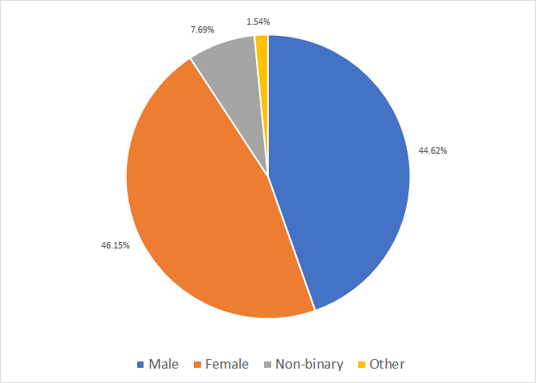

**Figure 2**

*College class of respondents*

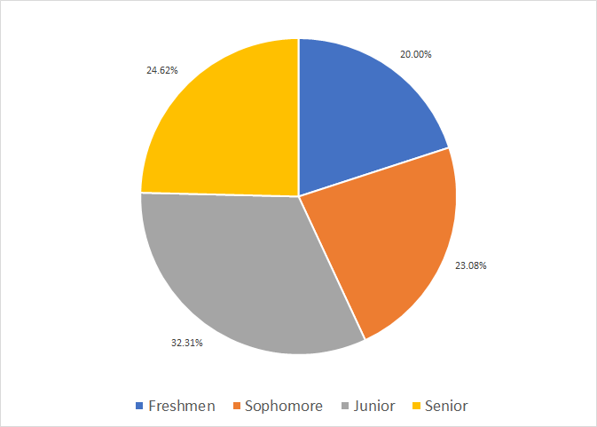

The majors of the different respondents also varied greatly. There was a noticeable concentration towards Information Technology and Computer Science, making up approximately 29% of the responses. The “other” category in Figure 3 constitutes all the majors that had 1 respondent.

**Figure 3**

*Majors of Respondents*

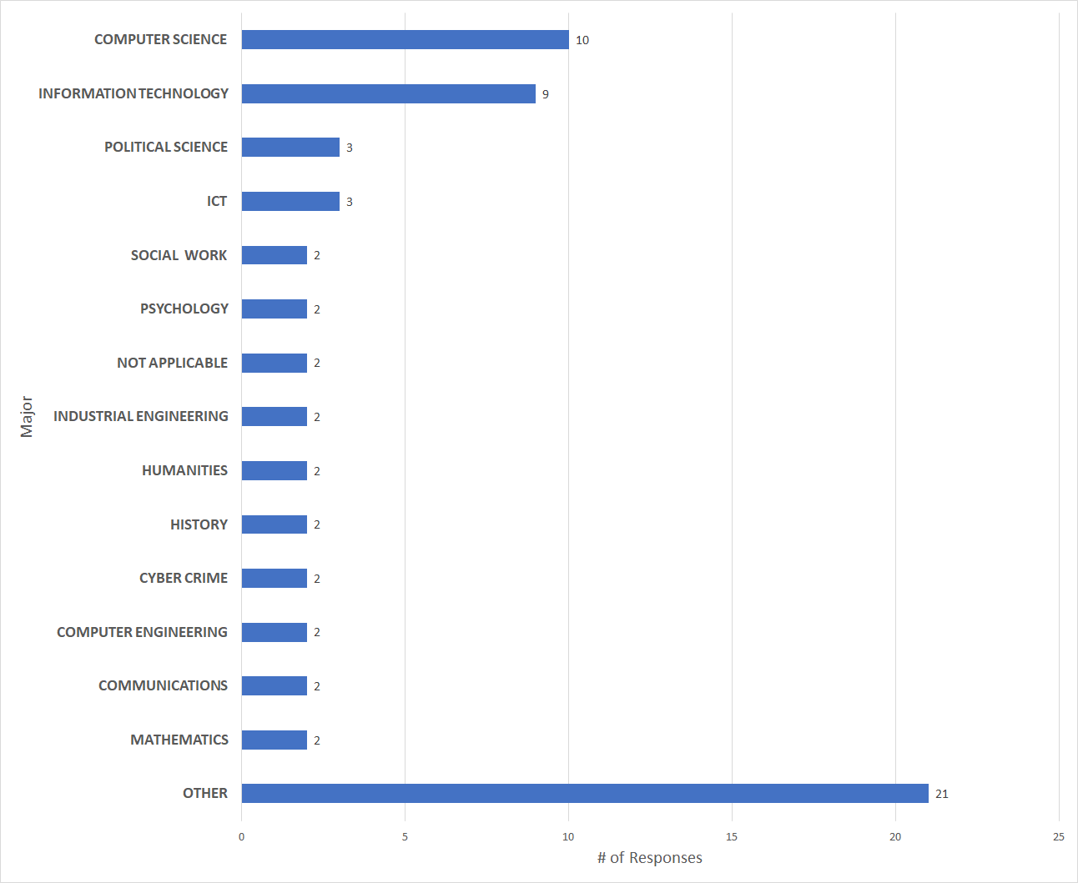

**RQ 1: What effect(s) does the gendered digital divide have on the educational experience of FSU undergraduates?**

In order to determine the effect of the gendered digital divide on education, students were first asked whether or not they had taken a STEM course, where issues in the digital divide are most prevalent.

80% of survey respondents claimed they had taken a STEM course before. Of those that did take a STEM course, their reasoning for doing so varied.

**Figure 4:**

*Reasons for taking STEM courses*

| Needed for major/minor | 52.31% |
| --- | --- |
| Personal interest | 24.62% |
| Good job opportunities | 23.08% |
| Other | 0% |

Survey takers were also asked whether they believed FSU was providing assistance/guidance in the promotion of STEM courses; Figure 5 shows these results. The gender of the respondents has also been included to show that a majority of those who said “yes” are male, while a majority of those who said “no” are female.

**Figure 5:**

*Responses as to whether FSU was providing assistance/guidance in promoting STEM courses*

| Yes | 47.77% | Male | 64.7% |
| --- | --- | --- | --- |
| Female | 35.3% |
| No | 52.78% | Male | 36.8% |
| Female | 52.6% |
| Non-binary | 10.5% |

Students were also asked whether they believed STEM programs were at a disadvantage and why, specifically in the context of gender diversity. 25% of female respondents and 17% of male respondents claimed that there is no gender-based disadvantage present. Many respondents highlighted the need for diversity and varied perspectives in STEM. Respondents worried about the limited perspectives of an exclusively male body.

**RQ 2: How do students at FSU recognize the Digital Divide between the number of women in STEM vs the number of men in STEM?**

Respondents were also asked questions regarding their ability to perceive the digital divide in relation to gender representation.

Those who had taken a STEM course were asked whether they felt represented by their demographic in said courses. 57% of female respondents felt that they were not represented in the classroom due to the disparity between male and female students. By comparison, 27% of men felt that they were not represented in the classroom. Respondents commented on the fact that online school has made such disparities difficult to recognize. Men were also more likely to comment on other lacks of representation, such as ethnicity.

Students were also asked whether they felt they had equal access to STEM resources. Only 17% of respondents claimed they felt at a disadvantage. 70% of female respondents and 93% of male respondents felt they had equal access to resources. In terms of being given equal access to resources, there appears to be no discernable difference based on gender.

Students were asked, on a scale of 1-5, if they believed that FSU’s STEM programs valued diversity. The average of the responses was a 3.33 with a standard deviation of 1.03. When asked how strongly participants felt about increasing women’s involvement in FSU’s STEM programs, the average of the responses was 4.06 with a standard deviation of 1.10 (See Figure 6).

**Figure 6:**

*Average responses to numerical survey questions*

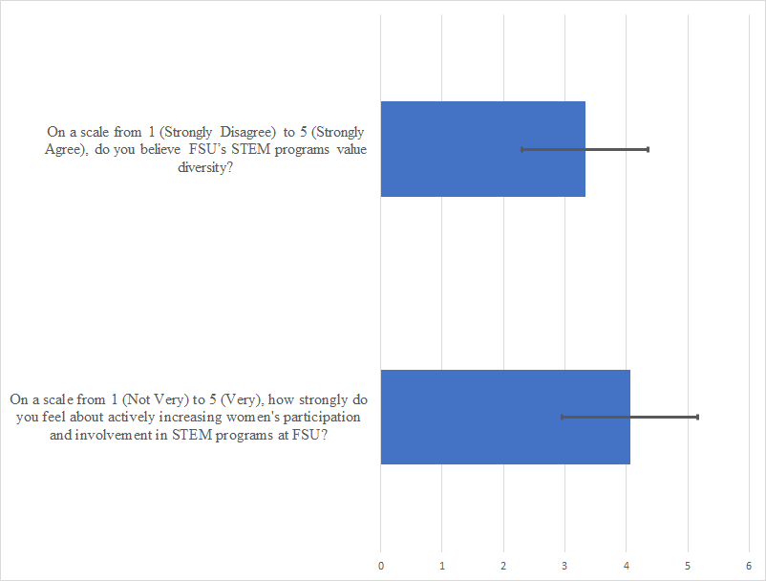

Students were asked to estimate the percentage of STEM majors that were women. On average, students predicted that 33.17% of STEM majors were female. The actual percentage of female STEM majors at FSU is 47.68%, significantly larger than the expected average (Office of Institutional Research, 2021). Compared to the national average, 38.60%, the difference is less recognizable (NSF NCSES, 2019). Students at FSU appear to underestimate the prevalence of women in STEM (See Figures 7-9).

**Figure 7:**

*Average expected percentage of female STEM majors*

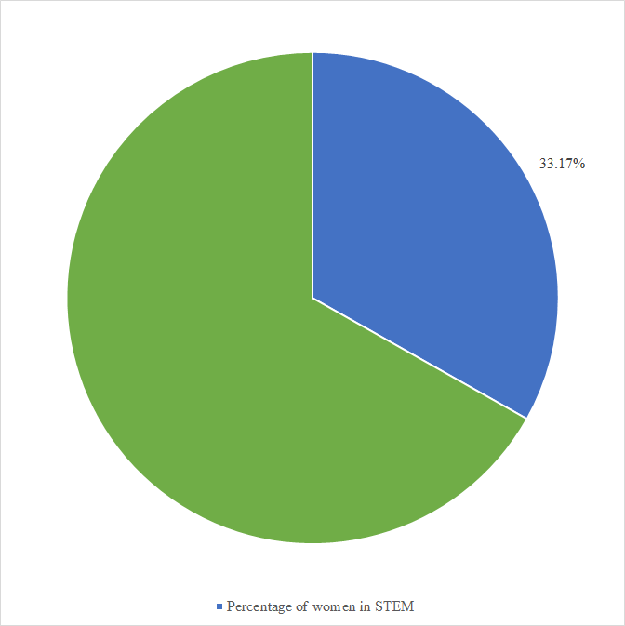

**Figure 8:**

*Average observed percentage of female STEM majors (FSU)*

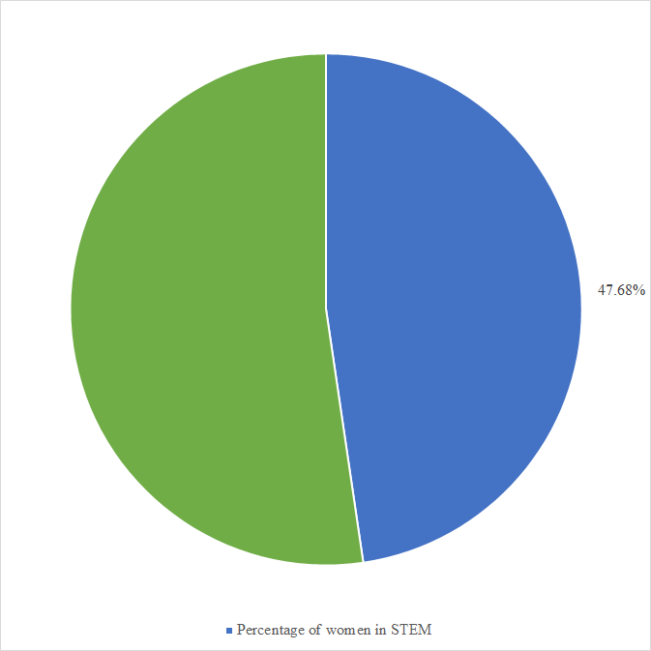

**Figure 9:**

*Average observed percentage of female STEM majors (nationwide)*

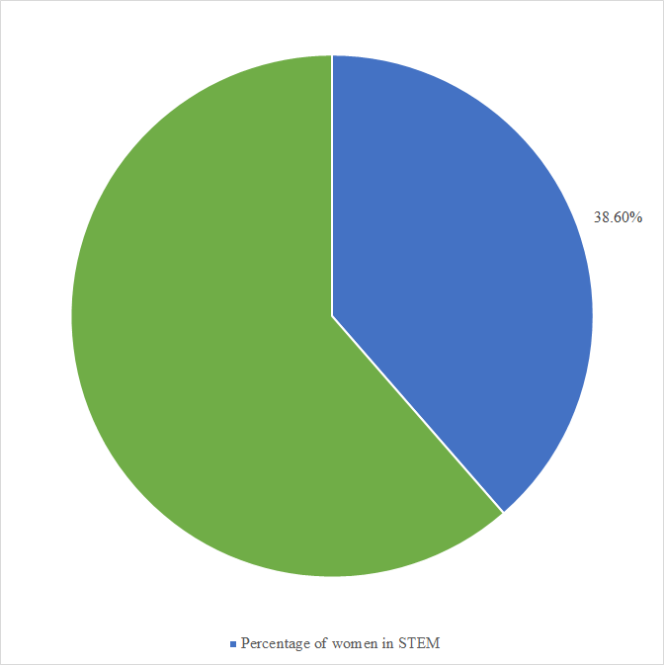

A common trend in the short response questions was women feeling discomfort in STEM courses. Female respondents often cited feeling uncomfortable in classes due to the imbalance of men versus women in classes. One female respondent claimed that she found it difficult to find teammates in classes due to her gender, claiming that men would often form groups together. Another respondent noted that when she speaks to academic advisors, they seem surprised by her previous success in STEM courses. This experience seems to trouble other female responses, as another wrote that she struggles dealing with the preconceived notions of being a woman in STEM. Other responses dealt with feelings of isolation and that their ethnicity furthered their feelings of discomfort in STEM environments.

# **Discussion**

**RQ#: Content of RQ#**

The findings for RQ1 conclude that there are effects that the gendered digital divide has on the educational experience at FSU among undergraduates. For instance, among the students who believed that FSU was providing assistance in the promotion of STEM courses, a majority who said “yes” were male, while most of those who said “no” were female. Students surveyed were also asked whether they believed STEM programs were at a disadvantage and why, specifically in the context of gender diversity. Many of the respondents highlighted the need for diversity and varied perspectives in STEM.

These findings mean that the students do believe there is a gendered digital divide at FSU, with a disadvantageous effect on their educational experience. They believe, particularly in STEM courses, that there needs to be a greater push for gender diversity. For example, on average, estimations have revealed that in 2019, 49% of women were expected to complete a university STEM degree. However, in reality, only 28% of women enrolled and completed a STEM degree (Mostrafa, 2019). This disparity reinforces the belief that women are less likely to participate in STEM programs. The significance of this is that STEM students at universities, such as FSU, actually do believe there is an inequality in their educational experience based on gender. This is something that needs to be adjusted for the future and improved upon if they could do more to encourage gender diversity in STEM.

The findings for RQ2 conclude that students were not able to recognize the Digital Divide between the number of women in STEM versus the number of men in STEM at FSU. The students were asked to provide an estimate of the percentage of STEM majors that were women at FSU. The students surveyed predicted that 33.17% of STEM majors were female. However, the actual percentage of female STEM majors at FSU is 47.68%, which is significantly higher than the expected average (Office of Institutional Research, 2021). Compared to the national average, which is 38.60%, there is a less noticeable difference (NSF NCSES, 2019). It seems that the students at FSU appear to underestimate the prevalence of women in STEM.

This is significant because it demonstrates that the students thought the disparity among women in STEM and men in STEM was a lot worse than it actually was. However, the fact that they thought the percentage was that low probably proves that to them there may be a gender disparity. Thus, they should make an effort to highlight the gender diversity in STEM courses at FSU.

**Limitations/Future Study**

Quite simply, a limitation for this study is the number of respondents. Although 75 students were enough to draw basic conclusions from, in order to represent the entire population of Florida State University undergraduate students, many more responses have to be collected. When considering the majors of the respondents, it is clear that respondents of our survey are not representative of the general population of Florida State students. In the future, this can be remedied by diversifying our outreach methodology and engaging with certain populations which we find lacking in our demographics. Furthermore, with more time we could have also reached a larger number of students. Similarly, if you are to conclude anything about the entire undergraduate collegiate population of a country, even more responses will have to be collected. In this case, we suggest that other universities conduct similar research in the scope of their own undergraduate student population. By congregating data and comparing research results, researchers could make more scientific generalizations of the population.

Additionally, our study had originally planned to supplement our research by including another form of data collection via an interview with select survey respondents. This step would collect more qualitative information, which could lead to a more robust understanding of the experience students have in STEM environments. For this step to be completed, the survey included contact information for interested persons to reach out to. Due to time constraints, we did not receive enough interest from survey respondents and were unable to continue with the interview process.

# **Conclusion**

In modern society, information and knowledge are widely distributed through the use of technology. The technologically capable have access to an increasing number of platforms, including but not limited to social, healthcare, entertainment, and educational services. With technology continuing to advance and ingraining itself in the fabric of our lives, those without access to technology are at risk of being left behind. In the academic setting, this idea manifests itself in the program that a student concentrates in; it is especially evident when examining the gender of students that take up STEM studies.

Our study investigated the divide in the gender of STEM students at Florida State University. Specifically, through a survey circulated through a variety of online student spaces, we collected both qualitative and quantitative data about the perception of the gendered digital divide at FSU and the impact of the disparity on the educational experience of each respective demographic. We conclude that work must be done to address the gap between the perceived digital divide and the reality of the digital divide. Our quantitative analysis determined that on average, students perceive that women make up 33.17% of STEM classrooms. In reality, the estimated percentage of women in STEM at FSU is 47.7%; with the national average being 38.6% (Office of Institutional Research, 2021; NSF NCSES, 2019). Our qualitative analysis determined that 57% of women feel underrepresented in the FSU STEM classrooms, compared to 27% of men feeling that way. In addition, the vast majority of both men (93%) and women (70%) feel that they are given equal access to the resources needed to succeed in STEM.

The discrepancy between the reported divide at FSU and women’s experience at FSU leaves room for further analysis. While women generally report feeling underrepresented in STEM environments at FSU, they also feel as if they have equal opportunities to succeed given the resources provided to them. In this case, we suggest that resources be allocated to furthering the study, where more women can be interviewed and the levels of discomfort can be evaluated more thoroughly. Our group also suggests that supplementary research must be done at other universities to better grasp the divide at large.

# **Reflections**

Vanessa Sanabria:

Before this class I never created and implemented a study to be distributed. One of the biggest things I learned were the multiple steps it took to create a fully formed study and the background work that needs to be done before you even create the survey. I learned about how much thought and clarity you need for the topic you are going to choose and the amount of research needed for every part of the study. Aside from learning about the long process of creating a study, there was a lot to be learned about our peers at Florida State and their thoughts about the digital divide. It was interesting seeing what men and women thought about the lack of representation in the STEM field.

The main challenge we faced while creating our study is the survey distribution. It was hard to gather up a total of 100 respondents since many did not want to, we did not have an incentive to offer, and it was during the same time as many other groups were distributing their survey as well. Even from the students who did participate in the survey many did not complete it in its entirety. Some challenges I faced was trying to write in a very scientific manner as that is not my writing style, however, after reading many articles it has started to become easier to transform my thoughts into a clear academic and scientific manner. The last challenge was the irony of writing and studying the lack of women in STEM when I was the only woman in my group. This is something that is quite common in my LIS and is something I moved past. However, this gave me firsthand experience about what we were studying and had valuable knowledge and insight.

Brennan O’Hara:

This project was an amazing opportunity for my group members and I to conduct our own research project from scratch. We learned how to do everything from designing research questions to discussing survey questions and analyzing data. Throughout this process the most important things I learned were how to analyze qualitative data and how to work effectively in a team.

Learning to analyze qualitative data using color codes was an extremely valuable lesson that can be used in a variety of different ways. I found it very helpful to separate information using these colors when it came to analyzing the responses at the end. Furthermore, it helped when writing discussion statements to have all the information easily accessible.

This was one of the first projects I have had that lasted an entire semester with the same group. With that being said, I was nervous to see how working on a project of this size would work out. However, working with my team members to tackle this assignment proved to be one of the most beneficial aspects of this project. I think we all worked well together and were able to bounce ideas off each other to find the best way of completing a task.

One of the biggest problems we had was just finding the time to complete the work. We had difficulty completing everything during class time. We solved this problem by dividing up the work and working on it individually. This gave us the ability to accomplish more work while also leaving time for us to review the assignment as a whole. Another problem we faced was finding participants for our study. With so many surveys going around, a lot of people are hesitant to take the time to add another to the list. We solved this issue by taking advantage of different resources such as Discord, Zoom, Blackboard, as well as GroupMe. This allowed us to reach a broader audience and diversify our data.

Daniel Jaramillo:

This project taught me many things, primarily about the statistics of FSU. The data analysis section, which I was the primary contributor of, led to interesting perspectives regarding women in STEM. The prevailing sentiment of discomfort found in many of the short responses was surprising to me, but also made sense. While FSU has significantly more women in STEM than the national average, that number is primarily due to women-skewed majors such as biology. Other STEM majors find women in an extreme minority, leading to understandable feelings of exclusion.

The primary challenge I faced when in charge of the data analysis was the sheer amount of data collected from only a ~20 question survey. While I had done some data analysis projects in my spare time before, working with short response questions was a new experience. Qualtrics helped greatly with the numerical data, as it would automatically provide averages and standard deviation for calculation purposes. I am thankful that I had team members to assist with the process, such as pasting the responses into a Google Doc and providing numerical analysis of the short responses.

Another issue faced was the creation of graphics for the data. Deciding which data sets should use tables, pie charts, bar graphs, etc. proved more challenging than expected. Being colorblind also made designing the pie charts difficult, as I worried that I was inadvertently making them visually displeasing. The comments on the progress report helped decide what to convert into charts. In terms of coloring, I relied on my peers to review the graphs to make sure they were legible.

Oliver Veras:

Undergoing the process of a research study proved to be more difficult than I had originally anticipated. For one, I could not imagine completing this project if it weren’t for an active and consistently communicating team. Though the work was sometimes admittedly pretty time consuming and we would routinely not have enough time to complete our work during the allotted class time, we always worked around our strengths and weaknesses; largely letting group members pick whatever they wanted to work on. I think this kept us motivated and made it easier to finish assignments on our time. Outside of learning how to work on a work intensive project through a distributed team, I also learned something about FSU students. Our study found that the STEM population at FSU is actually quite balanced, at least compared to the collegiate average. Having taken courses in each branch of the STEM domains, I noticed a similar trend myself. Though a disparity definitely exists, that gap was much closer, or even flipped, in some of my courses. For example, I was one of very few men in my Biology and Statistics courses, the split between men and women in Physics classes seemed to be pretty evenly distributed, and my Computer Science courses were easily less so, with very few women being in those classes. It’s interesting that in spite of this, FSU students seem to think that this gap is bigger than the reality.

At first, one large challenge we faced was that our schedules were incompatible, for the most part. Whenever one of us had an open schedule in between or after classes, someone else had a class to attend or had to go to work. This made it very difficult to meet up virtually. We ended up scrapping the idea in general and decided to meet on Fridays during the allotted time, distribute the workloads, and get our work done before the due date, individually. We also had a group message to send any questions we might have while working.

Deven Ugalde:

A research study assignment turned out to be far more challenging than I thought it would. I faced a variety of challenges throughout the entire assignment, while also learning a lot of things along the way. I learned a lot of new things that go into a research study. I never have done an environmental scan, as well as, interpreting the qualitative data. However, luckily I didn't face these challenges alone, and found that as a group it was much easier to navigate and do. I also learned about the statistics detailing gender diversity in STEM among FSU students. I realized that the gendered digital divide may not be as bad as originally anticipated. However, there are still improvements to be made within the STEM courses at FSU because there were cases where people didn’t feel represented. There were many challenges I faced as well. I found it personally difficult to deal with and use all the different data within the contents of a survey. I also didn’t realize how much detailed planning went into this type of research study. Also, it was interesting to use qualtrics as a survey, which was another new thing I had to use. Overall, I feel like I learned a lot this semester about a research study and the content of our own research study. Also, the group dynamic was very helpful and was similar to how actual research studies are done, which is in a group setting. I never was alone in facing the challenges and week by week was able to learn more.

Jamel Douglas:

I've done research-style assignments in the past, but nothing compares to what this assignment entailed. This assignment, and the ones that came before it, put my skills to the test and allowed me to learn a couple of new things. The first of those things is how to create a proper research survey. I have had previous experience with making an online survey, but this assignment took that to a whole different level. For example, we were able to use Qualtrics for our online survey and it is just on a completely different level in comparison to my previous experiences. Another skill that I learned was how to analyze qualitative question responses. In class, we learned how to color code based on categories to analyze qualitative data. This was something that I had no prior knowledge of, so it was great to learn something new.

One of the challenges that I faced while working on this assignment was time management. It was hard to finish the assignments in the time that was allotted for class. It was also hard for the group to meet up outside of class time due to conflicting schedules, which left us delegating certain tasks to each other. I would also like to point out how this large assignment being done in groups helped me work on my teamwork skills, something that I think is going to be essential in my future endeavors. This project just would not have been possible if it were not for my great team members. Great communication throughout the semester.

References[LB2]

Barboni G., Field E., Pande R., Rigol N., Schaner S., Moore C. T. (2018). *A tough call: understanding barriers to and impacts of women’s mobile phone adoption in India*. Harvard Kennedy School. https://www.hks.harvard.edu/publications/tough-call-understanding-barriers-and-impacts-womens-mobile-phone-adoption-india

Brown, J. (2021). *Creating a culture of diversity, equity, and inclusion: Real progress requires sustained commitment*. Harvard Business Review Analytic Services. https://hbr.org/sponsored/2021/09/creating-a-culture-of-diversity-equity-and-inclusion

Ice, L., & Zilberman, A. (2021). *Why computer occupations are behind strong STEM employment growth in the 2019–29 decade* (Beyond the Numbers: Employment & Unemployment, Series 10, Issue 1)*.* U.S. Bureau of Labor Statistics. https://www.bls.gov/opub/btn/volume-10/pdf/why-computer-occupations-are-behind-strong-stem-employment-growth.pdf

Joel Cooper, & Kimberlee D. Weaver. (2003). *Gender and computers: understanding the digital divide.* Psychology Press. https://web-a-ebscohost-com.proxy.lib.fsu.edu/ehost/ebookviewer/ebook?sid=1c502e0c-02ba-4419-bed3-775ad2be1b8a%40sessionmgr4007&vid=0&format=EB

KewalRamani, A., Zhang, J., Wang, X., Rathbun, A., Corcoran, L., Diliberti, M., & Zhang, J. (2018). *Student access to digital learning resources outside of the classroom* (NCES Publication No. 2017-098). U.S. Department of Education: National Center for Education Statistics. https://nces.ed.gov/pubs2017/2017098.pdf

Liff, S., & Shepherd, A. (2004). An evolving gender digital divide? *Oxford Internet Institute.* Internet Brief No. 2.

Lund, S., Manyika, J., Segel, L. H., Dua, A., Hancock, B., Rutherford, S., Macon, B. (2019). *The future of work in America: people and places, today and tomorrow*. McKinsey Global Institute. https://www.mckinsey.com/featured-insights/future-of-work/the-future-of-work-in-america-people-and-places-today-and-tomorrow

Mostafa, T. (2019). *Why don’t more girls choose to pursue a science career?* (PISA in Focus, Issue 93). Organisation for Economic Cooperation and Development Publishing. https://doi.org/10.1787/02bd2b68-en.

National Science Foundation National Center for Science and Engineering Statistics. (2019). *Women, Minorities, and Persons with Disabilities in Science and Engineering: 2019.* (Special report NSF 19-304). https://ncses.nsf.gov/pubs/nsf19304/data

Office of Institutional Research. (2021). FSU enrollment at a glance. Florida State University, Office of Institutional Research. Retrieved December 3, 2021, from https://ir.fsu.edu/enrollment.aspx.

World Economic Forum. (2020). *The future of jobs report 2020*. https://www.weforum.org/reports/the-future-of-jobs-report-2020/in-full/

**Consent Form**

In the table below, list what contributions each of the team members made to this assignment.

| Name | Contribution |
| --- | --- |
| Jamel Douglas | Contributed to editing the “Data Collection Methods” and “Limitations/Future Study” sections, completed personal Reflection, participated in discussions with the group |
| Brennan O’Hara | Edited “Problem Statement” and participated in group verbal discussions |
| Daniel Jaramillo | Analysis category and participation in discussions |
| Oliver Veras | Contributed to vocal discussion, helped with formatting and editing, wrote “Conclusion” |
| Deven Ugalde | Participated in discussions, contributed to “Discussion”, “Population and Sample”, “Recruitment Site and Procedures” |
| Vanessa Sanabria | Gave input and participated in vocal discussions. Contributed by writing the abstract, formatting the project and proofreading. |
|  |  |

| Criteria | Rating |
| --- | --- |
| Abstract, Problem Statement, Significance, RQs: **11 points**  Appropriate abstract, problem statement, significance, and RQs (4 pts), in-text citations for all arguments (4 pts); revisions from research project report (3 pts) |  |
| Environmental Scan: **10 points**  Appropriate intro, subsections, and conclusion (3 pts), in-text citations for all arguments (4 pts), revisions from research project report (3 pts) |  |
| Methods: **9 points**  Finalized data collection method(s) (2pts), sampling technique(s) (2pts), and recruitment process (2 pts), revisions from research project report (3 pts) |  |
| Analysis: **19 points**  Sample description (2 pts); complete QUAL and QUAN findings for each research question (8 pts); include data/stats/quotes, analysis, and relate findings to RQ answers (6 pts), visualizations (3 pts) |  |
| Discussion: **18 points**  Summarize findings for all RQs (3 pts), provide interpretations/discussions for all RQs (12 pts), comparison/contrast with previous studies and citation needed (3 pts) |  |
| Limitations/Future Studies: **6 points**  Limitations (include generalizability issues discussion) (3 pts), future studies (3 pts) |  |
| Conclusion: **5 points**  Restate and highlight core findings (5 pts) |  |
| Reflection: **10 points (Individual)**  Reflection by team members (10 pts each) | 1)  2)  3)  4)  5)  6) |
| File Name, APA Style, Consent Form: **12 points**  File name (1 pt), proper citations and references (8 pts), match between reference list and citations, (2 pts), consent form (1 pt) |  |